Robotics Process Automation Design and Development (UiPath) – BCG701 Lab
Experiment No: 9
Title: Develop Excel automation in UiPath StudioX to demonstrate the following activities: Refresh Pivot Table, Append Range, Copy Range, Sort Range, Clear Sheet/Range/Table, Auto Fill, Fill Range, Write Range, Read Cell Formula, Read Cell Value, Format Cells, Export to CSV.

Aim: To develop an automation in UiPath StudioX that demonstrates Excel file automation by performing operations such as:
- Refresh Pivot Table
- Append Range
- Copy Range
- Sort Range
- Clear Sheet/Range/Table
- Auto Fill
- Fill Range
- Write Range
- Read Cell Formula
- Read Cell Value
- Format Cells
- Export to CSV

Theory:
- Refresh Pivot Table: The Refresh Pivot Table activity utilizes the Refresh feature in Excel to allow you to update the pivot table with any data changes that have occurred in the source data range.
- Append Range: The Append Range activity copies data from a specific sheet, range, or table and pastes/appends it after data in another sheet range or table.
- Copy Range: The Copy Range activity allows you to copy and paste a range, sheet, or table from one location to another in the Excel workbooks available to the automation.
- Sort Range: The Sort Range activity allows you to sort the data in a sheet, range, or table by one or multiple columns in Excel.
- Clear Sheet/Range/Table: The Clear Sheet/Range/Table activity allows you to clear data for a specified sheet, range, or table in the Excel workbooks available to the automation.
- Auto Fill: The Auto Fill activity utilizes the auto fill feature in Excel to fill data in adjacent cells (cells in the same column) based on existing data, similar to using the Fill option in Excel or dragging the Plus icon on the corner of a cell to other surrounding cells. Popular use cases for automatically filling data include date, text, number, or formula fields that need to be automatically filled into their adjacent fields in Excel.
- Fill Range: The Fill Range activity located allows you to insert text or formula into a specified range/table in the parent Use Excel File activity or Project Notebook.
- Write Range: The Write Range activity allows you to write data values from a range, table, sheet, or saved in the automation to another specified range in the Excel workbooks available to the automation.
- Read Cell Formula: The Read Cell Formula activity allows you to read a formula from a specified cell in an Excel workbook used in the automation.
- Read Cell Value: The Read Cell Value activity allows you to read the value from a specified cell in an Excel workbook used in the automation.
- Format Cells: The Format Cells activity updates the format of cells in a specified range. Format Cells activity will format all the cells in the specified range and override any existing formatting.
- Export to CSV: The Export to CSV activity allows you to export a range, sheet, or table from an Excel file to a CSV file.

Conduction:
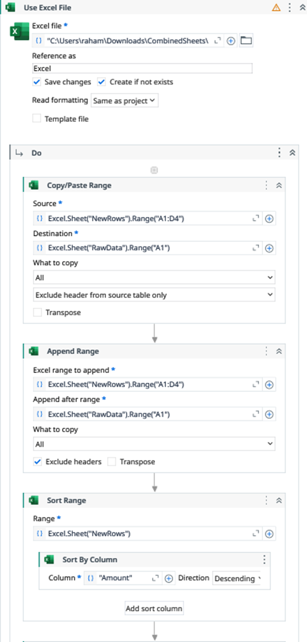

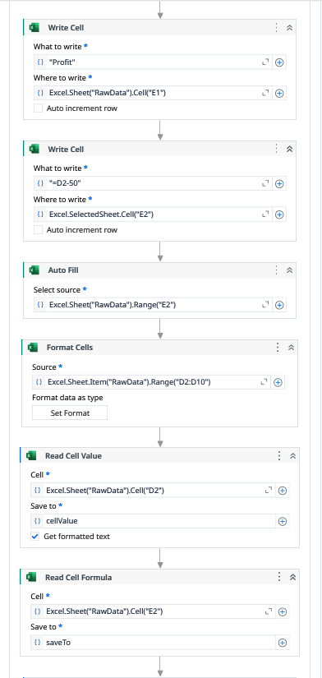

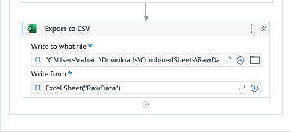

Output:
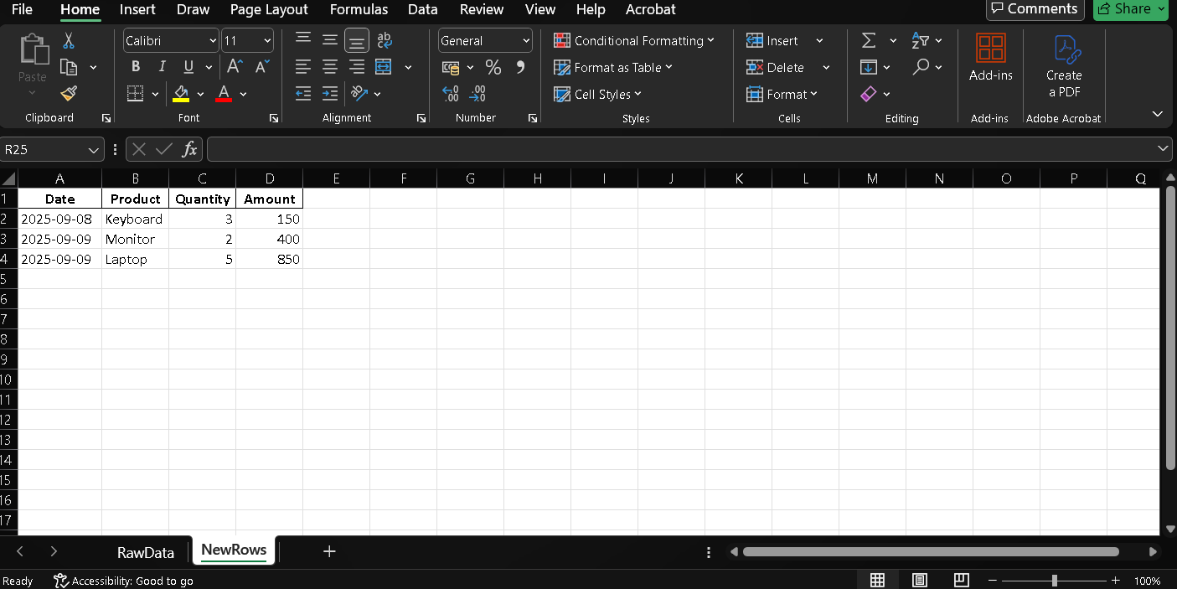

Observation and Results:
The following activities were successfully demonstrated in UiPath StudioX:
- Insert Rows
- Delete Rows
- Find First/Last Data Row
- For Each Excel Row
- Write Cell
- Create Pivot Table
- Save Excel File As
- Save Excel File As PDF
The output for the above-mentioned activities is verified.

Evaluation:
Evaluation Parameters | Maximum Marks | Obtained Marks
Conduction | 8
Record Writing | 4
Viva | 3
Total | 15

Signature of the Faculty in-charge with date:

